37.73: a) 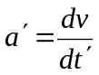 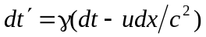
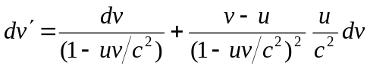
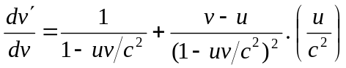
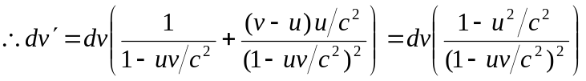
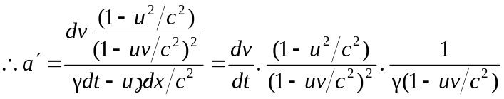
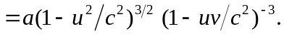
b) Changing frames from 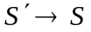just involves changing 